SQL Database Project: Kestrel Air Flight Operations Database
Olutayo Akinsola ADIGUN | Student ID: 25058362 | Synthetic regional airline database (SQLite) | Data Science | Individual report

1. Overview
The models are based on an imaginary regional airline in the UK, Kestrel Air, which operates a hub and spoke structure from Manchester and Edinburgh in 2026. It contains 10 related tables, 73 columns and approximately 344,000 rows. Five tables exceed the 1,000-row requirement: bookings (105,480), booking_extras (185,225), passengers (50,000), flight_cabins (2,158) and flights (1,073). The data is assumed to be extracted on 29 October 2026, so flights that have already taken place are history (with weather, delays and ratings) and those that have not taken place yet are only scheduled with a partial booking. All four scales of measurement are addressed (Section 3). The SQLite file will be named kestrel_air.db (approximately 30MB).

2. How the data was generated
All data was created by a single Python script, generate_airline_db.py (Section 6) with the sole use of the standard Python libraries (random, sqlite3, math, datetime, bisect). No external data downloaded. All passenger, flight and booking information is fictional, only the hand typed facts are general public knowledge and were used as parameters (IATA codes, approximate airport coordinates and elevations, typical aircraft seat counts and ranges, typical monthly temperatures). Fixed random seed (2026) makes the database the same each run (checked by hashing two runs). Tables are created in dependency order, that is, such that each foreign key reference is to a table that has already been created; values follow cause-and-effect rules and not uniform noise:
Network (airports 26, aircraft types 4, aircraft 8, routes 60). If there are 30 hub-to-destination pairs, there are a total of 60 hub-to-destination routes. Distances are calculated using the Haversine formula, and routes are categorized (Domestic, Business, Leisure, Mixed) and have a weekly frequency.
Flights (1,073) and flight cabins (2,158). The weekly frequency is multiplied by a seasonal factor, which reduces the number of departures (except for leisure routes, which are reduced during winter) and a weekday factor (which reduces the number of departures during August and at the weekend (except for business routes)) for each day of 2026. All aircraft are allocated according to time of flight and each aircraft has a range limit, and a turnaround of 45 mins (checked: 0 overlaps). Mean delay to departure: 7 min if clear, 19 min if thunderstorm, and 41 min if snow. Origin temp follows the airport's climate (seasonal curve + noise) and weather is a function of temp, and delays/cancellations depend on weather of origin temp and hour of day. Cabin capacity and list fares are based on aircraft configuration and distance, route type, month, weekday and cabin.
Passengers (50,000). Names are drawn from imaginary pools, e-mails are unique @example.com addresses, birth years are triangularly distributed between 1940 and 2008 (all adults), sign-up dates are skewed to be more frequent as the years pass and home country has a weight (62% UK). Loyalty tier is awarded after bookings (Silver, Gold and Platinum based on flights flown 3, 6 and 10+ respectively) and is not awarded randomly.
Bookings (105,480). Load factor is a function of route type, month / weekday and noise. Passengers have heavy-tailed (log-normal) activity weights, that is, a small number fly frequently, and a large number fly once or twice; only registered passengers are able to book. Lead time is log-normal (median ~ 3 weeks) and fares have a demand curve: economy fare £205 on average for booking 0-7 days in advance, and £122 on average for booking 31+ days ahead. Seats are unique to each flight. Status - Flown 87%, Booked (future) 7%, Cancelled 3%, No-show 2%, Refunded (flight cancelled) 1%. Only price of flown bookings and about two thirds of passengers respond to the question of satisfaction (1 to 5), with the average given being 4.15 when the flight is on time, dropping to 3.07 when the flight is 60+ minutes late.
Add-ons (booking_extras 185,225; extras 12). Association-rule mining is deliberately linked with purchase probabilities (bag with priority boarding, lounge with fast track, hot meal with drink) to provide real rules, e.g. lounge access -> fast track security (confidence 0.59, lift 4.1).
Validation. No foreign key violation was detected after loading, no integrity check found any violations, no booking is signed up before the passenger is booked or after departure, and no cabin is oversold.

3. Database schema
There are 10 tables in a schema and they are connected using foreign keys (figure 1). The following table lists the four measurement scales covered by the columns, dates and times have been stored in ISO-8601 text.
Scale | Columns
Nominal | weather_condition, flight_status, route_category, booking_status, payment_method, booking_channel, home_country, region, extra_name, extra_category, manufacturer, engine_type, iata_code, names
Ordinal | cabin_class (Economy < Premium Economy < Business), loyalty_tier (Standard < Silver < Gold < Platinum), satisfaction_rating (1 to 5)
Interval | origin_temperature_c, scheduled_departure and scheduled_arrival (ISO text), booking_date, signup_date, birth_year, year_built, elevation_m, latitude, longitude (zero is arbitrary)
Ratio | fare_gbp, base_fare_gbp, unit_price_paid, list_price_gbp, checked_baggage_kg, departure_delay_min, arrival_delay_min, distance_km, seats_capacity, quantity, weekly_frequency, range_km
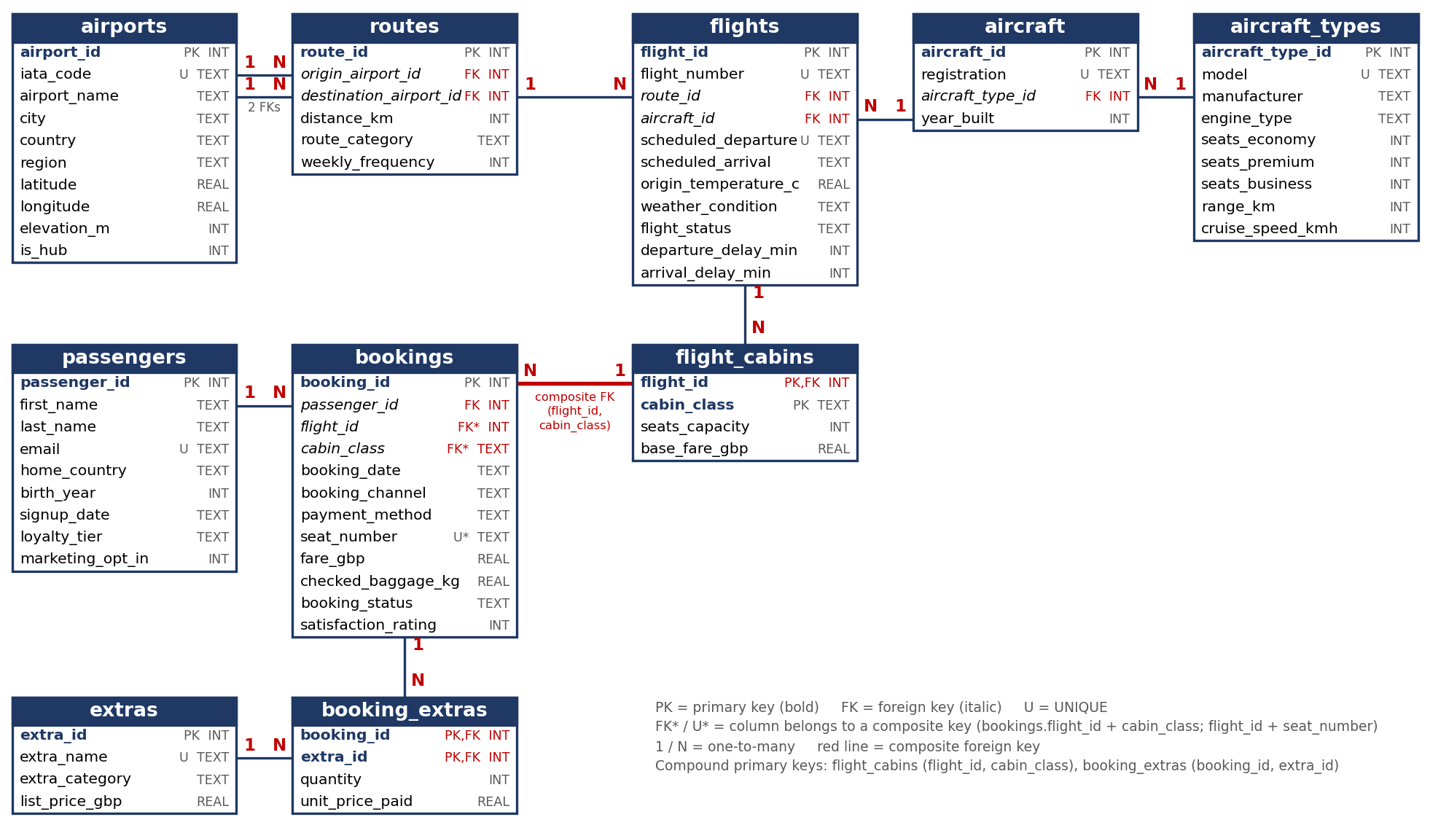
Figure 1: Entity relationship diagram: 10 tables, 73 columns, compound and composite keys marked.

4. Justification for separate tables and constraints
Table | Rows | Reason for a separate table
airports | 26 | Airport facts are stored once and referenced twice by routes (origin and destination) instead of being repeated on every flight.
aircraft_types, aircraft | 4, 8 | Seat layout, range and speed belong to the model, not to each aeroplane (third normal form); eight aircraft reference four types.
routes | 60 | Distance, category and frequency belong to a directed airport pair. UNIQUE (origin, destination) prevents duplicate routes.
flights | 1,073 | One row per departure, holding the facts that vary per flight: times, weather, status and delays.
flight_cabins | 2,158 | Capacity and list fare differ per flight and cabin, so they need their own table. Compound primary key (flight_id, cabin_class).
passengers | 50,000 | Person details are stored once rather than repeated on each booking.
bookings | 105,480 | Resolves the many-to-many link between passengers and flights (one row per seat). The composite foreign key (flight_id, cabin_class) guarantees that the cabin really exists on that flight.
extras | 12 | Lookup of add-ons and list prices; avoids inconsistent spellings.
booking_extras | 185,225 | Resolves the many-to-many link between bookings and extras and records the price paid. Compound primary key (booking_id, extra_id) stops the same add-on being listed twice; it is the basket-style table used for association rules.
Constraints. SQLite enforces all foreign keys if you set PRAGMA foreign_keys = ON. All tables have a primary key, and all fields are required to have the NOT NULL constraint. When using UNIQUE, the following iata_code, registration, model, email, extra_name, (origin, destination), (flight_number, scheduled_departure) and (flight_id, seat_number) is applied, which means that a seat cannot be sold twice. Status and category lists, rating 1 to 5, latitude between −90 and 90, birth_year between 1920 and 2008 (adult account holders), fare > 0, baggage ≥ 0, delays in a fixed range, origin ≠ destination: all these are handled by CHECK constraints. The values of columns are NULL only when the value is truly unknown: weather, delays (for future flights), seat_number (after a passenger cancelled, the seat is released), checked_baggage_kg (until the passenger checks in), satisfaction_rating (when they did not answer the satisfaction question in the survey; 71% of bookings). This provides real missing data to deal with in subsequent preparation. Foreign keys and date indexes improve the performance of joins and date-based queries.

5. Ethical and data privacy discussion
Synthetic data. There is no actual person represented; hence, no consent or re-identification issue. As names are in generic pools and a mere coincidence with a real person is nothing, e-mails are sent using a domain name reserved for documentation only and are therefore not contactable. There was no copying of any third party data set.
The design is made to look as though it is real. This schema is in line with the principles of the UK GDPR and Data Protection Act 2018. It reduces data (birth year instead of date, home country instead of address, no phone number, passport number, card number or special-assistance/health flag; only the payment type is retained) and provides purpose limitation with the marketing_opt_in consent flag. For a live system, the passengers would be pseudonymised, access would be restricted, retention periods would be determined and erasure would consist of anonymising the passenger while retaining flight data.
Re-identification and fairness. If the individual is a member of a small population, then aggregation prior to sharing would be required because they could be identified by home country, birth year, loyalty tier and booking dates. Tiered benefits/pricing may bring disbenefits to last-minute or regular travelers and would require a fairness assessment. Unhappy passengers are more likely to respond to the survey.
Limits of realism. Distributions are based on my assumptions, not real behavior: the schedule is thinned (eight aircraft, about three flights a day), times are local, no positioning flights are stored, and passenger are sampled independently for each flight, which means that one passenger may have two bookings in close times. The database needs to be displayed to show technique and cannot be used as evidence of an existing airline or its clients.

6. Code
The entire generator is commented throughout to explain each design decision, and is contained in generate_airline_db.py (c. 850 lines). It can be found on GitHub / Google Collab as a repository / notebook: https://github.com/Olutayo122/SQL-db. A copy of kestrel_air.db is perfectly recreated when you run python generate_airline_db.py.

7. Evidence: first rows of each generated table
Figures 2-11 are screen shots of the kestrel_air.db in a database viewer with the first 4 rows of each table displayed, with counts of the number of rows in each table shown in the table headers.
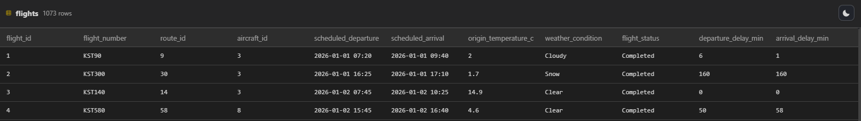
Figure 2. flights (1,073 rows): weather, status and delays
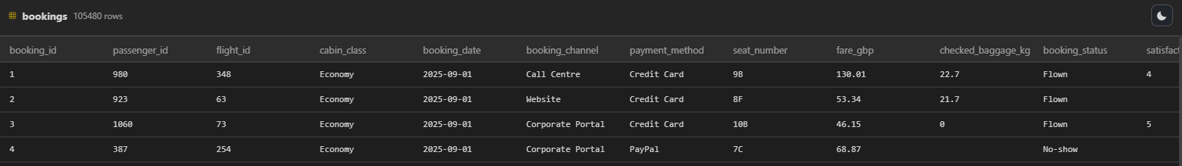
Figure 3. bookings (105,480 rows): composite-key columns, fares, status and NULL baggage or ratings
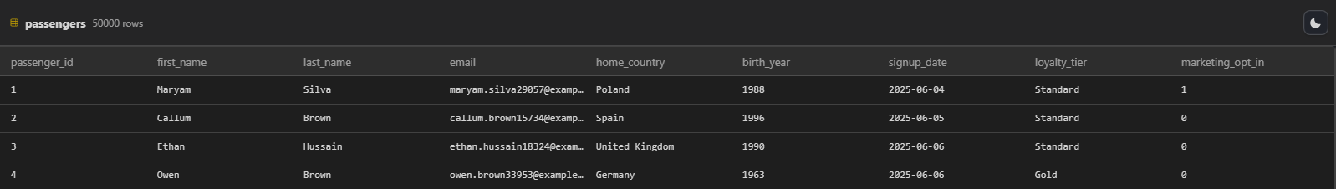
Figure 4. passengers (50,000 rows): synthetic names, example.com e-mails, derived loyalty tiers
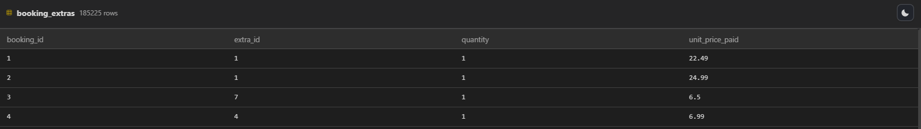
Figure 5. booking_extras (185,225 rows): compound key (booking_id, extra_id)
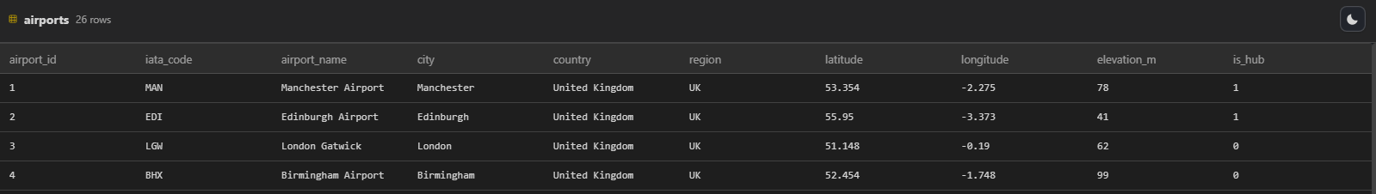  Figure 6. airports (26 rows) | 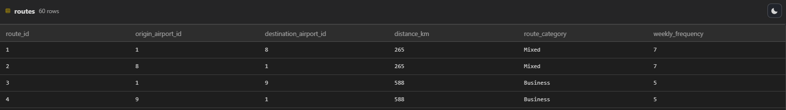  Figure 7. routes (60 rows)
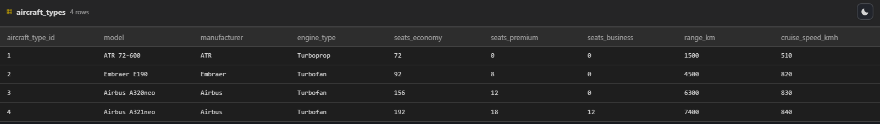  Figure 8. aircraft_types (4 rows) | 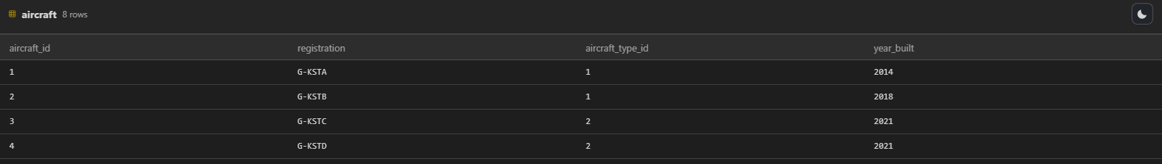  Figure 9. aircraft (8 rows)
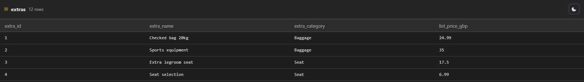  Figure 10. extras (12 rows) | 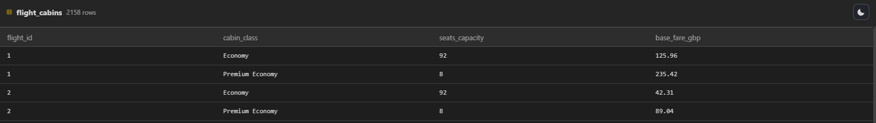  Figure 11. flight_cabins (2,158 rows)

